CREATING INSTANCE FOR LINUX:

22A81A05G0

STEP 1: After entering into EC2 dashboard launch an instance and copy the public ip address and then connect to the instance

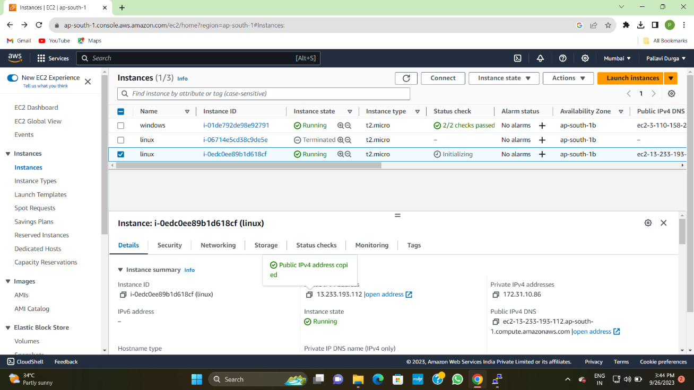

STEP 2: Now will get a pop-up notification as shown

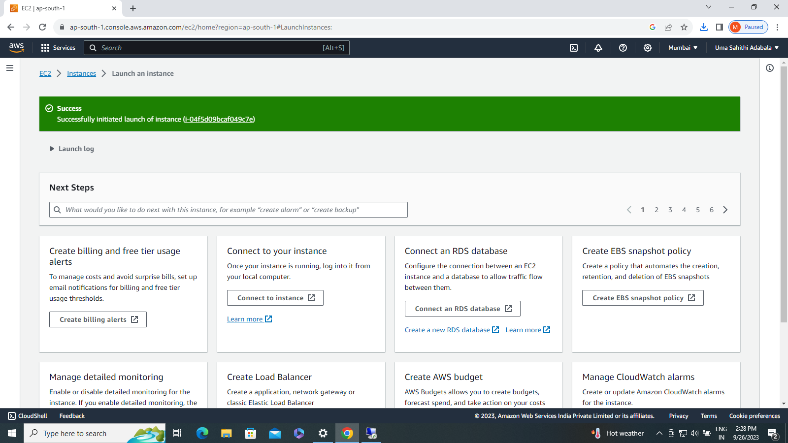

STEP 3: Now open putty gen and load an existing private key file and save private key file

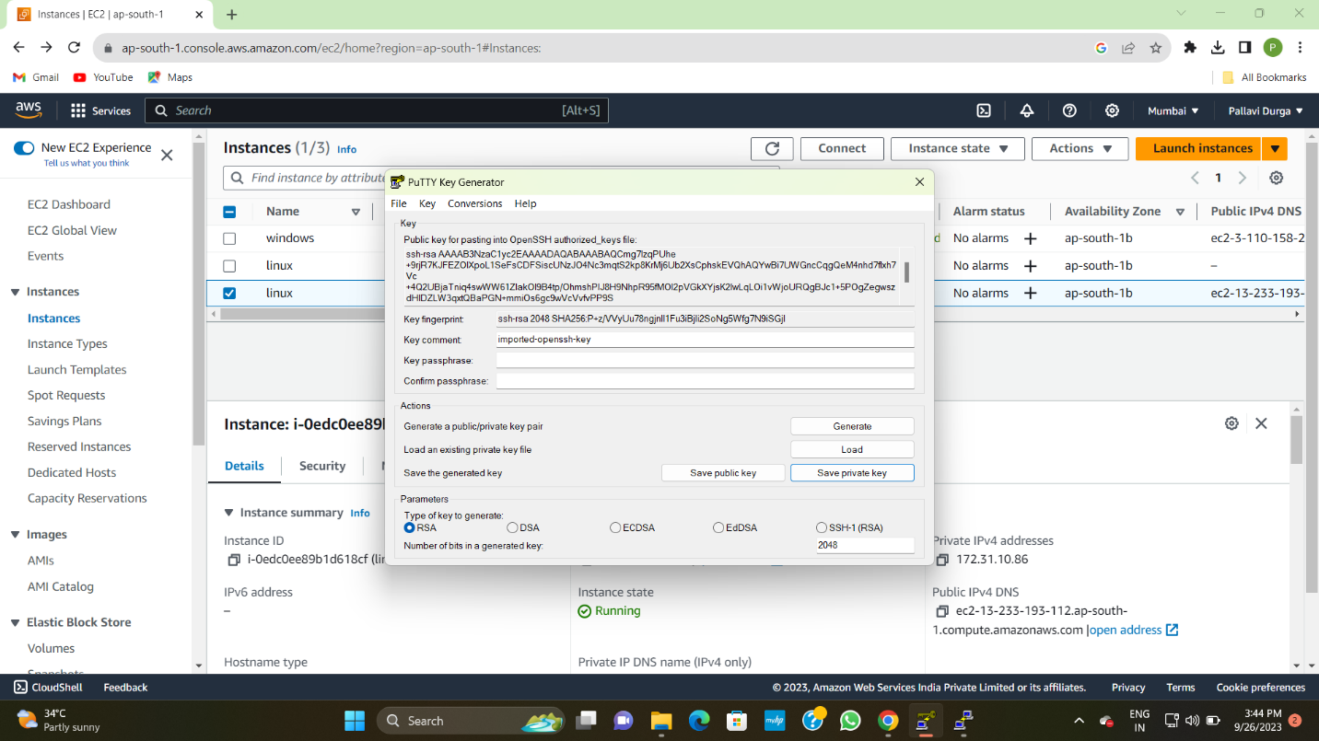

STEP 4:Now open putty and enter the ip address and then click on credential to authenticate with in auth which in ssh finally click on open.

Now linux operating system will be opened then you have to enter login user name

